**Lab Assignment - 1**

**1.Create an ASP.Net page that shows the use of Ad Rotator****.**

**Adrotater.aspx**

<%@ Page Language="C#" AutoEventWireup="true" CodeBehind="Adrotater.aspx.cs" Inherits="WebApplication1.Assignment_1.assignment2.Adrotater" %>

<!DOCTYPE html>

<html xmlns="http://www.w3.org/1999/xhtml">

<head runat="server">

<title>Ad Rotator</title>

<style>

/* Set the entire page background to black */

body {

background-color: black;

margin: 0;

font-family: Arial, sans-serif;

color: white; /* Set text color to white for visibility */

display: flex;

justify-content: center;

align-items: center;

flex-direction: column;

min-height: 100vh; /* Ensures content is centered vertically */

}

/* Style for the name container */

.text-container {

text-align: center;

margin-bottom: 20px;

padding: 20px;

background-color: rgba(255, 255, 255, 0.1); /* Semi-transparent background */

border-radius: 8px;

box-shadow: 0 4px 8px rgba(0, 0, 0, 0.5); /* Box shadow for text box */

}

.text-container p {

margin: 0 0 0;

font-size: 1rem;

color: #cccccc;

}

/* Style for the AdRotator container */

.ad-container {

margin-top: 20px;

padding: 10px;

background-color: white;

border-radius: 8px;

box-shadow: 0 4px 8px rgba(0, 0, 0, 0.5); /* Box shadow for AdRotator box */

}

.ad-container img {

display: block;

max-width: 100%;

border-radius: 8px;

}

</style>

</head>

<body>

<form id="form1" runat="server">

<!-- Name and other information -->

<div class="text-container">

<p>Name : Kashish Koshiya<br />Enrollment No : 22SOECE11031</p>

</div>

<!-- AdRotator section -->

<div class="ad-container">

<asp:AdRotator ID="AdRotator1" runat="server" AdvertisementFile="~/Assignment 1/assignment2/XMLFile2.xml" />

</div>

</form>

</body>

</html>

**XMLFile2.xml:**

<?xml version="1.0" encoding="utf-8" ?>

<Advertisements>

<Ad>

<ImageUrl>\Assignment 1\assignment2\img\asp.net1.jpeg</ImageUrl>

<Keyword>ASP.NET</Keyword>

<NavigateUrl>https://dotnet.microsoft.com/en-us/apps/aspnet</NavigateUrl>

<AlternateText>asp.net</AlternateText>

<Impression>2</Impression>

</Ad>

<Ad>

<ImageUrl>\Assignment 1\assignment2\img\asp.net core.png</ImageUrl>

<Keyword>ASP.NET CORE</Keyword>

<NavigateUrl>https://dotnet.microsoft.com/en-us/apps/aspnet</NavigateUrl>

<AlternateText>asp.net core</AlternateText>

<Impression>2</Impression>

</Ad>

</Advertisements>

**Output Screenshot:**

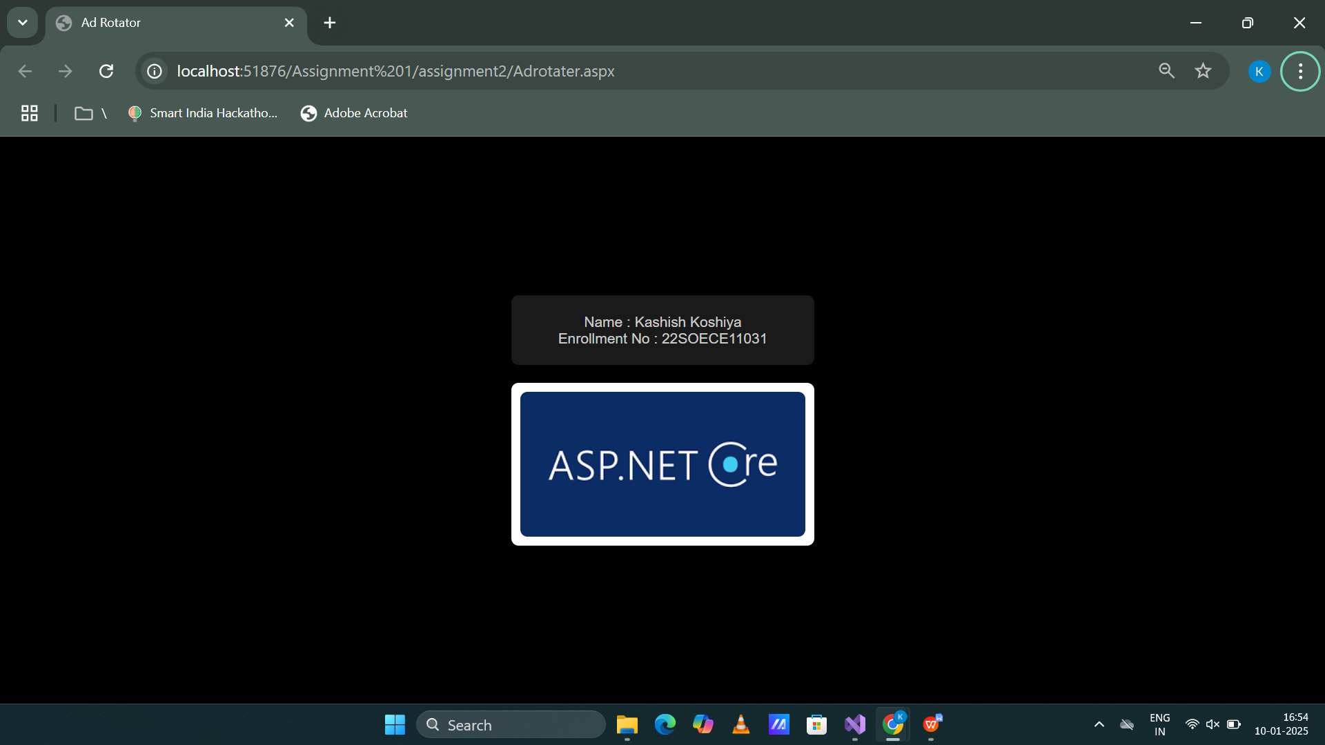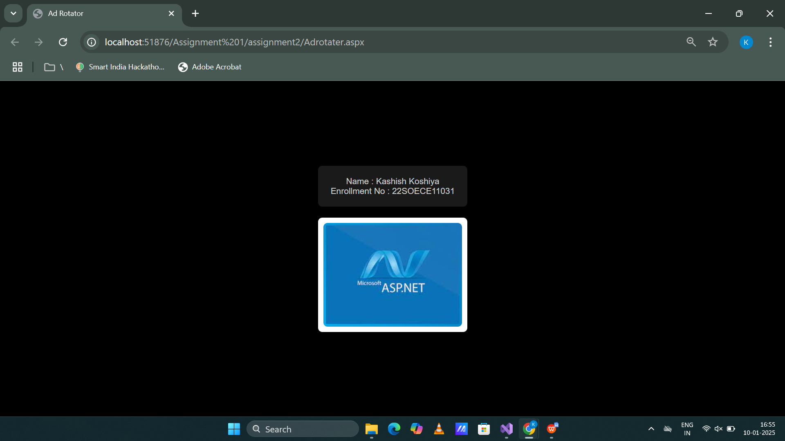

**2**.**Create an ASP.Net page that shows current day and also display selected date.**

**day.aspx Code:**

<%@ Page Language="C#" AutoEventWireup="true" CodeBehind="day.aspx.cs" Inherits="WebApplication1.Assignment_1.assignment2.day" %>

<!DOCTYPE html>

<html xmlns="http://www.w3.org/1999/xhtml">

<head runat="server">

<title>Calendar Example</title>

<style>

/* Body styling */

body {

background-color: #000000; /* Black background */

font-family: Arial, sans-serif;

color: #ffffff; /* White text */

margin: 0;

padding: 0;

display: flex;

flex-direction: column;

align-items: center;

justify-content: center;

min-height: 100vh;

}

/* Container for user details */

.text-container {

text-align: center;

margin-bottom: 20px;

padding: 20px;

background-color: #001f3f; /* Dark blue background */

border-radius: 10px;

box-shadow: 0 4px 8px rgba(0, 0, 0, 0.5);

width: 90%;

max-width: 400px;

}

.text-container p {

margin: 0;

font-size: 1.2rem;

color: #ffffff; /* White text */

}

/* Calendar container */

.calendar-container {

text-align: center;

margin: 20px 0;

padding: 20px;

background-color: white; /* Dark blue background */

border-radius: 10px;

box-shadow: 0 4px 8px rgba(0, 0, 0, 0.5);

width: 90%;

max-width: 400px;

}

/* Styling for the calendar */

.calendar-container table {

width: 100%;

border-collapse: collapse;

color: #ffffff; /* White font for text */

}

.calendar-container th {

background-color: #001f3f; /* Dark blue for headers */

color: #87CEEB; /* Light blue for header text */

padding: 10px;

}

.calendar-container td {

text-align: center;

padding: 10px;

cursor: pointer;

}

.calendar-container td a {

text-decoration: none;

color: #ffffff; /* White font for dates */

}

.calendar-container td a:hover {

color: #87CEEB; /* Light blue on hover */

}

.calendar-container .selected {

background-color: #87CEEB; /* Light blue for selected date */

color: #000000; /* Black text for selected date */

font-weight: bold;

}

/* Labels for current day and selected date */

.labels {

margin-top: 20px;

font-size: 1.1rem;

color: #87CEEB; /* Light blue for labels */

text-align: center;

}

.labels p {

margin: 10px 0;

}

/* Responsive adjustments */

@media (max-width: 600px) {

.text-container,

.calendar-container {

padding: 15px;

}

.text-container p,

.labels p {

font-size: 1rem;

}

}

</style>

</head>

<body>

<form id="form1" runat="server">

<!-- User Details -->

<div class="text-container">

<p>Name: Kashish Koshiya<br />Enrollment No: 22SOECE11031</p>

</div>

<!-- Calendar -->

<div class="calendar-container">

<asp:Calendar ID="Calendar1" runat="server" OnSelectionChanged="Calendar1_SelectionChanged"></asp:Calendar>

</div>

<!-- Labels -->

<div class="labels">

<p>

<asp:Label ID="Label1" runat="server"></asp:Label>

</p>

<p>

<asp:Label ID="Label2" runat="server"></asp:Label>

</p>

</div>

</form>

</body>

</html>

**day.aspx.cs Code**

using System;

using System.Collections.Generic;

using System.Linq;

using System.Web;

using System.Web.UI;

using System.Web.UI.WebControls;

namespace WebApplication1.Assignment_1.assignment2

{

public partial class day : System.Web.UI.Page

{

protected void Page_Load(object sender, EventArgs e)

{

if (!IsPostBack)

{

// Display the current day on page load

Label1.Text = "Today is: " + DateTime.Now.ToString("dddd, dd MMMM yyyy");

}

}

protected void Calendar1_SelectionChanged(object sender, EventArgs e)

{

// Display the selected date from the calendar

Label2.Text = "Selected Date: " + Calendar1.SelectedDate.ToString("dddd, dd MMMM yyyy");

}

}

}

**Output Screenshot:**

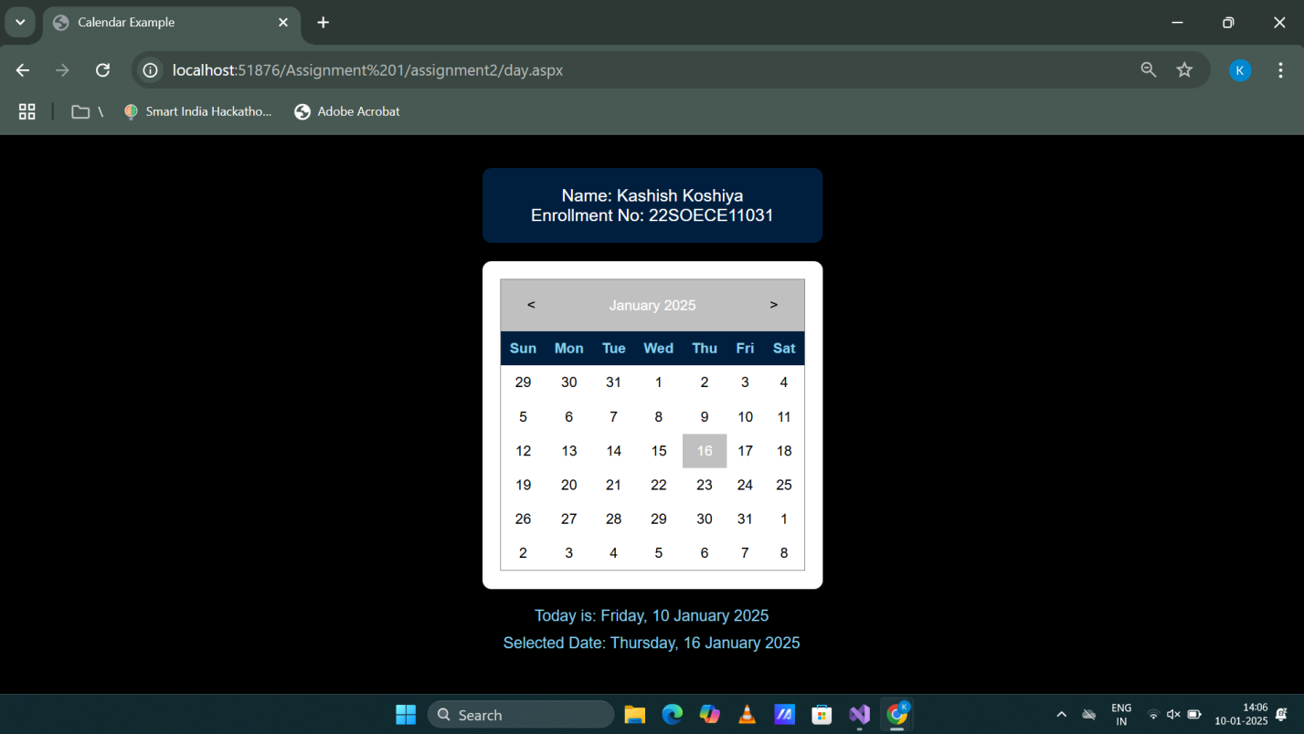

**3.Demonstrate the use of File Upload control.**

**Fileupload.aspx.cs Code:**

using System;

using System.Collections.Generic;

using System.IO;

using System.Linq;

using System.Reflection.Emit;

using System.Web;

using System.Web.UI;

using System.Web.UI.WebControls;

namespace WebApplication1.Assignment_1.assignment2

{

public partial class fileupload : System.Web.UI.Page

{

protected void Page_Load(object sender, EventArgs e)

{

}

protected void Button1_Click(object sender, EventArgs e)

{

if (FileUpload1.HasFile)

{

try

{

string filepath = Server.MapPath("~\\uploads\\") + Path.GetFileName(FileUpload1.FileName);

// Ensure the "Uploads" folder exists

Directory.CreateDirectory(Server.MapPath("~\\uploads\\"));

// Save the file to the specified path

FileUpload1.SaveAs(filepath);

// Display a success message

Label1.Text = "File uploaded successfully! File name: " + FileUpload1.FileName;

}

catch {

Label1.Text = "Error:";

}

}

else

{

// Display a message if no file was selected

Label1.Text = "Please select a file to upload.";

}

}

}

}

**fileupload.aspx Code**

<%@ Page Language="C#" AutoEventWireup="true" CodeBehind="fileupload.aspx.cs" Inherits="WebApplication1.Assignment_1.assignment2.fileupload" %>

<!DOCTYPE html>

<html xmlns="http://www.w3.org/1999/xhtml">

<head runat="server">

<title>File Upload Example</title>

<style>

/* General Page Styling */

body {

background-color: black;

color: white;

font-family: Arial, sans-serif;

margin: 0;

padding: 0;

display: flex;

justify-content: center;

align-items: center;

height: 100vh;

flex-direction: column;

}

/* User Details Section */

.text-container {

text-align: center;

margin-bottom: 20px;

padding: 20px;

background-color: #001f3f; /* Dark blue background */

border-radius: 10px;

box-shadow: 0 4px 8px rgba(0, 0, 0, 0.5);

width: 90%;

max-width: 400px;

}

.text-container p {

margin: 0;

font-size: 1.2rem;

color: #ffffff; /* White text */

}

/* File Upload Section */

.file-upload-container {

display: flex;

flex-direction: column;

justify-content: center;

margin-top: 30px;

padding: 20px;

background-color: rgba(255, 255, 255, 0.1); /* Semi-transparent white */

border-radius: 10px;

width: 100%;

max-width: 500px;

margin-left: auto;

margin-right: auto;

box-shadow: 0px 4px 10px rgba(0, 0, 0, 0.7);

}

/* File Upload Heading */

.file-upload-container h2 {

color: white;

margin-bottom: 20px;

}

/* File Upload Styling */

.file-upload-container input[type="file"] {

margin-bottom: 20px;

}

/* Button Styling */

#Button1 {

padding: 10px 20px;

background-color: #1E90FF;

color: white;

border: none;

border-radius: 5px;

cursor: pointer;

font-size: 1rem;

transition: background-color 0.3s ease;

}

#Button1:hover {

background-color: #4682B4; /* Darker blue on hover */

}

/* Label Styling */

.file-upload-container label {

margin-top: 20px;

font-size: 1rem;

color: #FFD700; /* Gold color for output */

text-align: center;

}

</style>

</head>

<body>

<form id="form1" runat="server">

<!-- User Details Section -->

<div class="text-container">

<p>Name: Kashish Koshiya<br />Enrollment No: 22SOECE11031</p>

</div>

<!-- File Upload Section -->

<div class="file-upload-container">

<h2>Upload File</h2>

<asp:FileUpload ID="FileUpload1" runat="server" />

<asp:Button ID="Button1" runat="server" OnClick="Button1_Click" Text="Upload File" /><br />

<asp:Label ID="Label1" runat="server" Text="Your file status will appear here."></asp:Label>

</div>

</form>

</body>

</html>

**OutputScreenshot:**

